**PRACTICAL-5**

**Usecase diagram of Railway Reservation System**:**-**

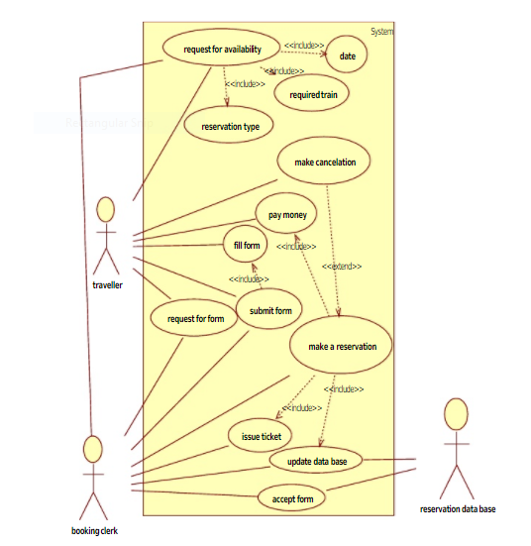

**Explanation:-**

|  |  |
| --- | --- |
| **Actor** | **Process Associated with Actors** |
| Traveller | Request for availability(date, required train, registration type), make cancellation, pay money, fill form, submit form, request form, make reservation |
| Booking clerk | Request availability, request for form, submit form, make reservation, issue ticket, update database, accept form |
| Reservation database | Update database, accept form |

**PRACTICAL-6**

**Usecase diagram of Restaurant bill:-**

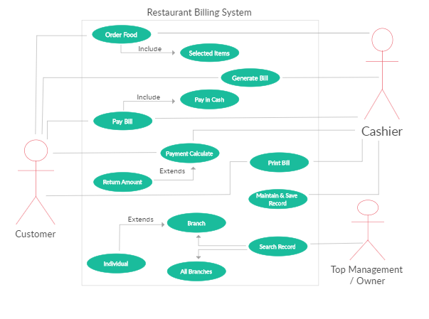

**Explanation:-**

|  |  |
| --- | --- |
| **Actor** | **Process Associated with Actors** |
| Customer | Order food(selected items), generate bill, pay bill(pay in cash), payment calculate, return amount, print bill |
| Cashier | Order food(selected items), generate bill, pay bill(pay in cash), payment calculate, print bill, maintain and save record |
| Top management / Owner | Search record(branch(individual), all branches) |

**PRACTICAL-8**

**(A)Facebook Application:-**

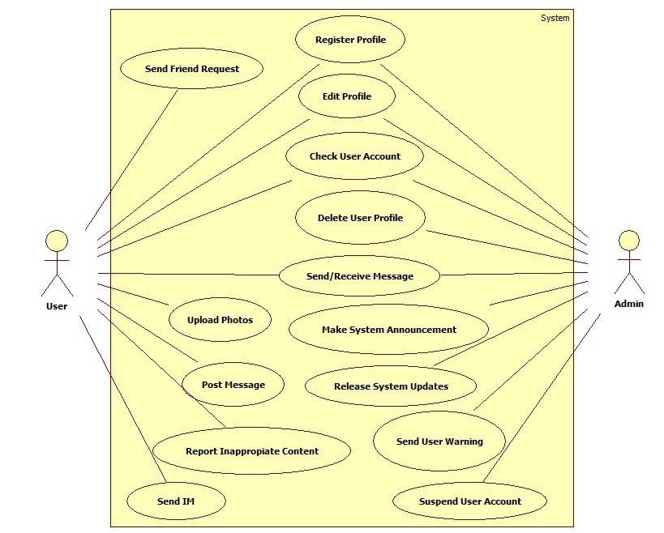

**Explanation:-**

|  |  |
| --- | --- |
| **Actor** | **Process Associated with Actors** |
| User | Register, send friend request, edit profile, check user account, delete user account, send/receive message, upload photos, post message, report inappropriate content, send im |
| Admin | Register, send friend request, edit profile, check user account, delete user account, send/receive message, make system announcement, release system updates, send user warning, suspend user account |

**(B)** **WhatsApp Application**.**:-**

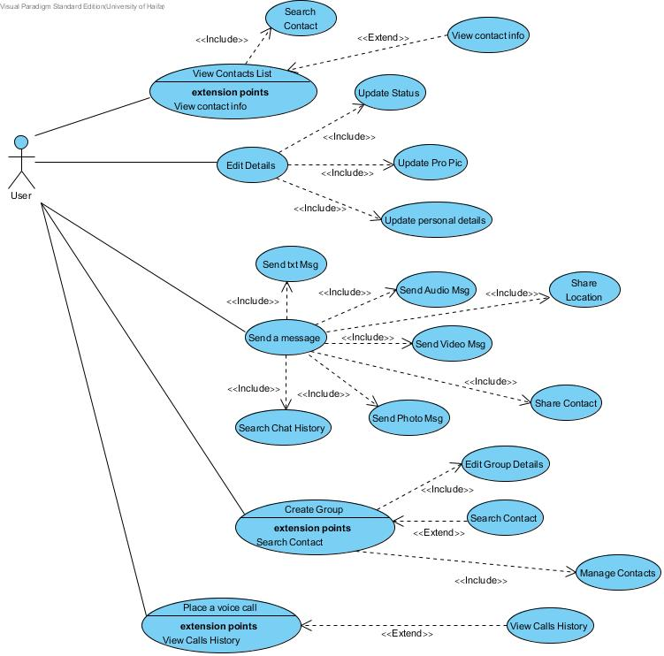

**Explanation:-**

|  |  |
| --- | --- |
| **Actor** | **Process Associated with Actors** |
| User | View contact list(search contact, view info), edit details(update status, update profile pic, update personal details), send message(send text message,search chat history, send audio msg, send video msg, send photo msg, share contact, share location), create group(edit group details, search contact, manage contact), place a video call(view call history) |

**(C)** **Library Management System:-**

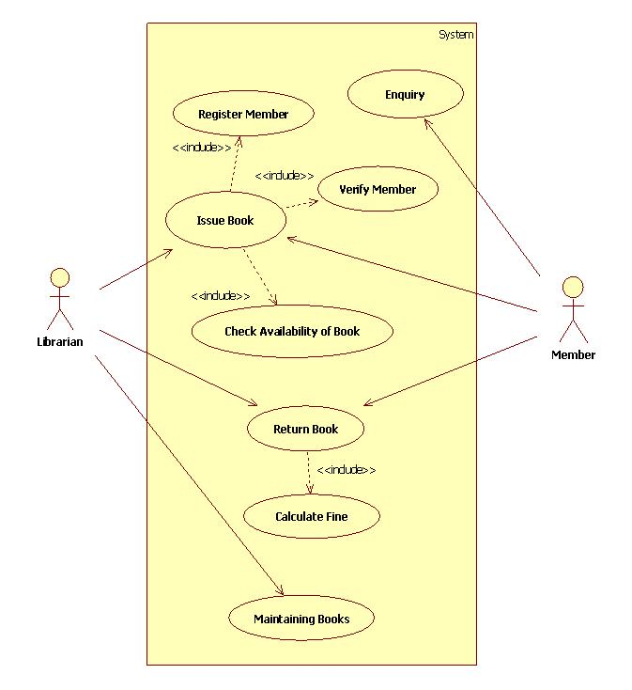

**Explanation:-**

|  |  |
| --- | --- |
| **Actor** | **Process Associated with Actors** |
| Librarian | Issue book(register member, verify member, check availability of book), return book(calculate fine), maintain books |
| Member | Enquiry, Issue book(register member, verify member, check availability of book), return book(calculate fine) |

**(D)** **Online Quiz System:-**

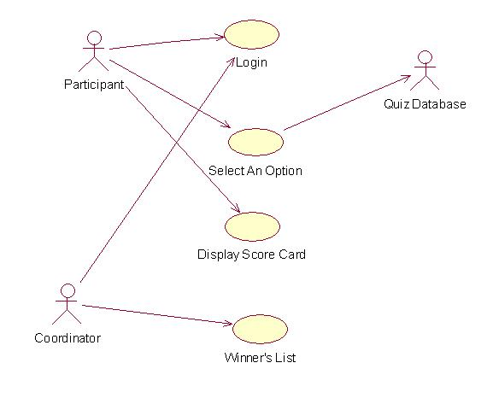

**Explanation:-**

|  |  |
| --- | --- |
| **Actor** | **Process Associated with Actors** |
| Participant | Login, select an option, display score card |
| Coordinator | Login, winner’s list |
| Quiz database | Select an option |

**(E)** **ATM System:-**

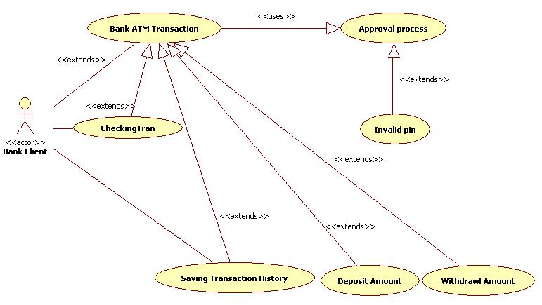

**Explanation:-**

|  |  |
| --- | --- |
| **Actor** | **Process Associated with Actors** |
| Bank client | Checking tran(bank ATM transaction), bank ATM transaction(Approval process), saving transaction history(bank ATM transaction), deposit amount(bank ATM transaction), withdrawl amount(bank ATM transaction), invalid pin(Approval process) |